Exam 2-Take Home
ACC 2020-Summer 2017

Name:_________________________________________

Problem 1 ______ (10)
Problem 2 ______ (10)
Problem 3 ______ (10)
Problem 4 ______ (10)

Total ____ (40)

You are to solve the three problems below. Your solutions must be submitted via Blackboard by 11am on July, 17th. Your solutions must be typed. Microsoft Excel is preferred, but feel free to use Microsoft Word as well. I will not accept any handwritten submissions. Show ALL of your work in a neat, orderly manner. If you have the incorrect answer, with no work to support it, you will not receive any credit. If you have the correct answer, with not work to support it, you will not receive full credit. Please label your answer clearly. This is an individual assignment. You are not to speak with classmates, tutors, parents, or anyone else about the problems or solutions to this exam. Doing so will result in “0”.

Problems – Please show your work.
- Woody’s Lumber manufactures both mulch and blocks as part of a joint production process. Joint costs up to the split-off point total $585,000 per batch. These joint costs are allocated to mulch and blocks in proportion to their relative sales values at the split-off point of $600,000 and $400,000, respectively.
Both products can be further processed by treating them to prevent decay. The following table summarizes the costs and revenue associated with additional processing of mulch and blocks:
 |  | Additional Processing Costs | Final Selling Price per batch of treated wood
Mulch |  | $ 1,500.00 | $ 9,000.00
Blocks |  | $ 2,500.00 | $ 6,000.00

Show your work!
(a) Which product (Mulch or Blocks) would result in a net decrease in operating income if processed into a commercial grade fertilizer?
____________
(b) Which product (Mulch or Blocks) would result in a net increase in operating income if processed into a commercial grade fertilizer?
____________

- Mitchum, Inc. produced different amounts of product X each month as follows:
Portable Enterprises produces two lines of mobile homes: double-wide and single-wide. Unit cost and revenue data pertaining to each product are shown below:
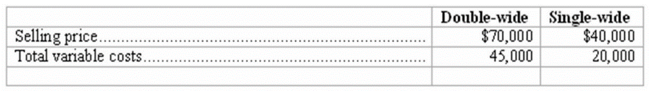
Each double-wide home requires 180 direct labor hours and 155 machine hours. Each single-wide home requires 245 direct labor hours and 120 machine hours. Demand for each line of homes far exceeds the company's total production capacity. Show your work!
(a) If Portable's production capacity is constrained by limited direct labor hours, which line of homes should it produce? ___________________
(b) If Portable's total production capacity is constrained by machine hours, which line of homes should it produce? ____________________

- Thomas Pee Co. has been producing a lens for a telescope they manufacture. The costs for this part are as follows:

Total Fixed Costs | 1880000
Total Variable Costs | 1460000
Units Produced | 26,000
Thomas Pee has an opportunity to purchase this lens rather than manufacture it. To purchase the lens will cost $98 per unit. If the part is purchased, fixed costs will be reduced by 15%.
Should Thomas Pee make or buy this part. Show how you arrived at your decision.

- Lights Out sells blinds and curtains. Its monthly fixed costs average $710,000. Blinds sales represent 25% of the company's total revenue. Curtains sales constitute the remaining 75%. The company has provided the following information expressed on a per-unit basis:

 |  | Selling Price | Direct Materials | Direct Labor | Manufacturing Overhead
Blinds |  | $ 12.00 | $ 4.00 | $ 2.00 | $ 3.00
Curtains |  | $ 24.00 | $ 8.50 | $ 7.00 | $ 2.50
Show your work!
(a) The total monthly sales revenue required to break-even is $__________.
(b) The total monthly sales revenue required to earn an operating income of $135,000 is $__________.
(c) The company's margin of safety at a budgeted monthly sales level of $2,500,000 is $__________.

